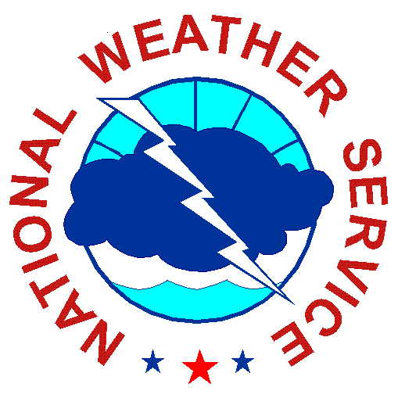
Science and Technology Seminar

The Impact of NWS Weather Forecast Office Culture on Tornado
Warning Performance in the Wake of the Joplin and Tuscaloosa Tornado Disasters

Stephan Smith

Office of Science and Technology
Meteorological Development Laboratory
Silver Spring, Maryland

The talk will discuss the impact of individual office cultures or “idiocultures” in National Weather Service forecast offices (WFOs) on tornado warning performance. A statistical analysis of the results of an employee satisfaction survey and tornado warning performance metrics (particularly False Alarm Rate), reveals the significant and enduring impact of culture on performance. A model of how WFO culture affects performance is proposed and strategies for improving performance based on changes to office culture are discussed.
Wednesday, November 30, 2011
2:00 – 3:00 p.m. E.T.
SSMC2, Room 2358

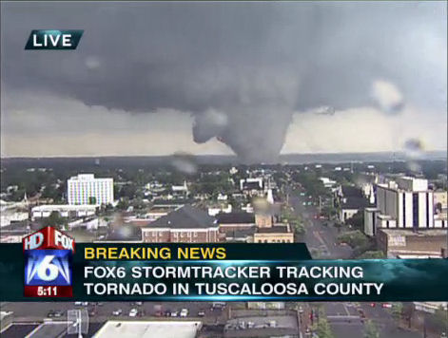

Wednesday,
September 7, 2011
2:00 - 3:00 p.m., E.T.
SSMC#2, Room 2358

(Contact: Bob Glahn at (301) 713-1768)

