Science and Technology Seminar

A Regression Model Designed for Ensemble Forecasts

David Unger

Climate Prediction Center
Camp Springs, Maryland

An ensemble forecast provides a dynamically derived estimate of the range of solutions from a numerical model. In general, numerical models require calibration in order to reduce the biases in their solutions, particularly at longer lead times. Regression has frequently been used to calibrate model output due to its ease of application and solid mathematical foundation. There are, however, some subtle challenges involved in the application of regression to ensemble forecasts.

A linear regression model especially designed for use on ensemble forecasts will be presented in this seminar. The ensemble regression model requires minimal additional overhead to derive or implement, in comparison to standard linear regression. Ensemble regression is ideally suited for use on long lead climate and weather forecasts where skill is low and information on the expected probability distribution of the forecast element is important. One of its favorable attributes is that the calibrated forecasts do not necessarily "regress to the mean" as is the case for standard regression applied to low skill forecasts. The ensemble regression forecasts also preserve the non-Gaussian forecast distribution predicted by the dynamic models. These and other statistical characteristics will be discussed in this talk. This forecast technique has been used at the Climate Prediction Center (CPC) on multi-model ensemble forecasts for 8-14 day temperatures from North American Ensemble Forecast System (NAEFS), as well as on forecasts from the NCEP Climate Forecast System (CFS). The regression procedure will be demonstrated on sea surface temperature forecasts from the CFS.

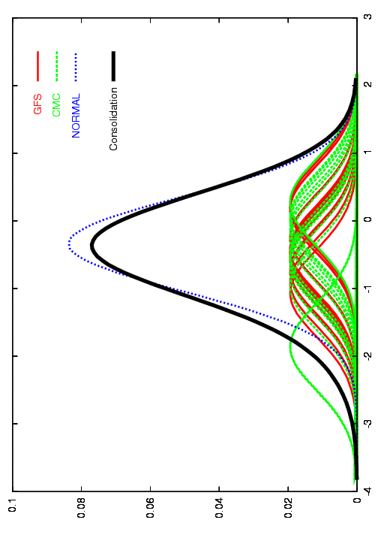
Wednesday,
September 21, 2011
2:00 – 3:00 p.m. E.T.
SSMC2, Room 2358

Wednesday,
September 7, 2011
2:00 - 3:00 p.m., E.T.
SSMC#2, Room 2358

(Contact: Bob Glahn at (301) 713-1768)

